

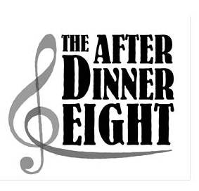
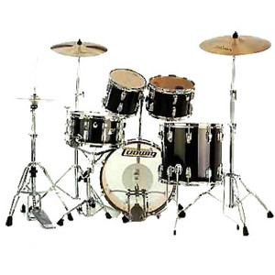
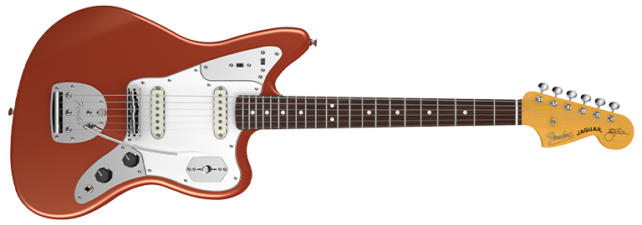
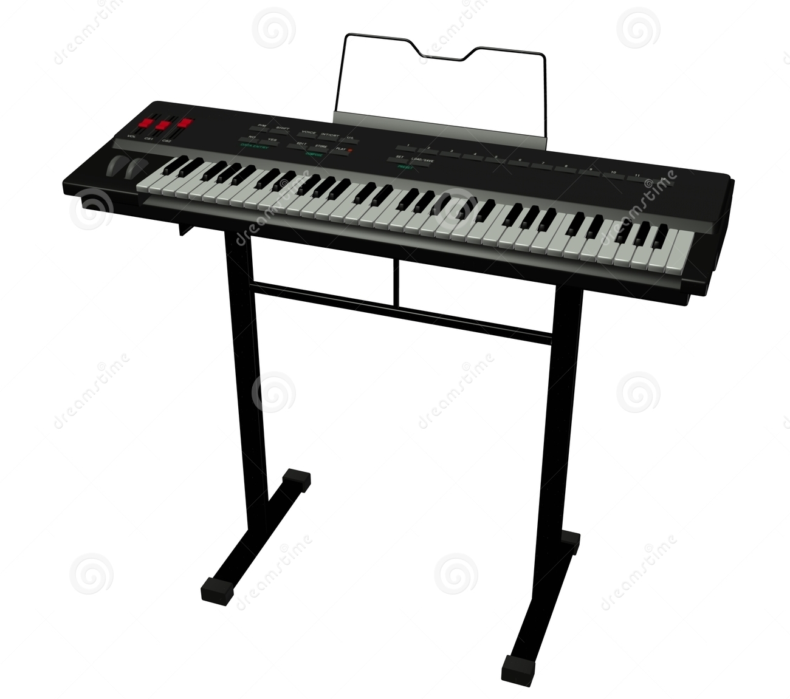
Songs of our Time

Brought to you by

A programme of songs that will get your feet tapping, hands clapping and spirits lifting!!

Saturday 14 October 2017 at 7.30pm
at West Grimstead Village Hall

Buffet Supper Bar Raffle

£10.00 for adults, £5.00 for children under 14
payable at the door

Please contact Janice Ford on 01722 710805 by 7 October
if you would like to come as this will
help with catering

IN AID OF WEST GRIMSTEAD VILLAGE HALL ROOF FUND

